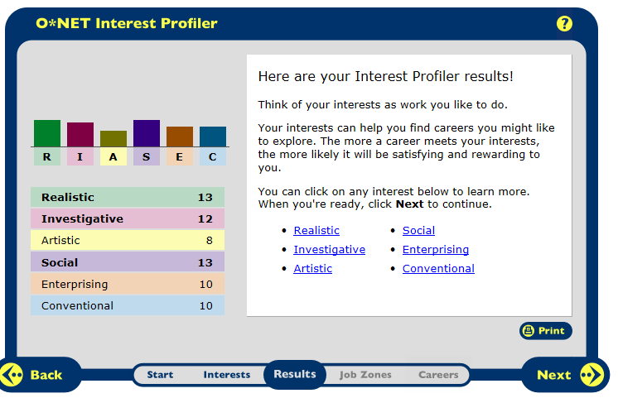

I agree with my scoring for my job interests but not entirely. I agree with it because I like to lead people and I always lead with a good example, I’m a very strong leader to others. I also agree with persuading others, because if something isn’t going well I can persuade everyone and make them look at the situation at a better point of view, and I’m really good at helping others at all times. The one thing that I disagree with is my conventional part of my test. I’m disagreeing with it because it said that I would follow a strong leader but usually I’m the leader that is leading unless it is someone who has been doing the job for years and I’m new to it. Usually when I’m doing something for a while I like to lead other people into what to do.

Career Research Data for 8 Career Occupations
Career Research Questions: | Athletic Trainer | Coach Or Scout | Special Agent | Electrician | Aircraft Mechanic | Ship engineer | Astronomer | Carpenter
HR1. Occupation Definition | Specialize in preventing, diagnosing, and treating muscle and bone injuries and illnesses. They work with people of all ages and all skill levels, from young children to soldiers and professional athletes | Teach amateur and professional athletes the skills they need to succeed at their sport. Scouts look for new players, evaluating athletes’ strengths and weaknesses as possible recruits. | Protect lives and property. Detectives and criminal investigators, who sometimes are called agents or special agents, gather facts and collect evidence of possible crimes. | Electricians install and maintain electrical systems in homes, businesses, and factories. | aircraft and avionics equipment mechanics and technicians repair and perform scheduled maintenance on airplanes and helicopters | Marine engineers and naval architects design, build, and maintain ships from aircraft carriers to submarines, from sailboats to tankers. | Astronomers study the fundamental nature of the universe, ranging from the vastness of space to the smallest of subatomic particles. | Construct and repair building frameworks and structures—such as stairways, doorframes, partitions, and rafters—made from wood and other materials.
HR2. Related Occupations | Chiropractors, Paramedics, Massage Therapists | High School Teachers, Athletes and Sports Competitors | Correctional Officer, EMT or Paramedic, Firefighter | Drafters, Line Installers or Repairers | Automotive Body and Glass Repairers, Electricians | Aerospace Engineers, Drafters, Mechanical Engineers | Civil Engineers, Chemists and Material Scientists, Biochemists and Biophysicists | Carpet Installers, Insulation Installers, Millwrights
HR3. Personality Type | You must be a hard worker because you need to know the human body to help the people who need help rehabilitating and getting back into shape. | Leadership and encouragement. | Good with talking to people | Good with crews and a team | Good with crews and welding | Good with crews and computers | Good with math, science and working alone. | Good with math and working with a crew.
HR4.Education | bachelor’s degree | High School Diploma or equivalent | High School diploma or equivalent | High School diploma or equivalent | Bachelors degree | Bachelor’s degree | Doctoral or professional degree | High school diploma or equivalent
HR5. Technology Skills | For being an athletic trainer you need to be good with computers for IMPACT testing and other computer tests | For being a coach or scout you need to be good with computers for IMPACT testing and other computer tests. | This job requires you to work well with computers for communication and information on people who may be wanted. | This job requires you to work well with computers, electrical sources, and monitors. | For this job you will need to be good with welding, and using tools or equipment for finding broken pieces or non-working parts in an aircraft. | In order to work well with this job you need to be good with welding, placement, and computers. | Particle accelerators and gamma ray telescopes. | Carpenters use many different hand and power tools to cut and shape wood, plastic, fiberglass, or drywall.
RC1. Salary | The median annual wage of athletic trainers was $41,600 in May 2010. | The median annual wage of coaches and scouts was $28,340 in May 2010 | The median annual wage of police and detectives was $55,010 in May 2010 | The median annual wage of electricians was $48,250 in May 2010. | : The median annual wage of aircraft mechanics was $53,420 in May 2010 | The median annual wage of marine engineers and naval architects was $79,920 in May 2010. | The median annual wage of physicists was $106,370 | The median annual wage of carpenters was $39,530
RC2. Job Growth | Employment of athletic trainers is expected to grow by 30 percent from 2010 to 2020, much faster than the average for all occupations. | Employment of coaches and scouts is expected to grow 29 percent from 2010 to 2020, much faster than the average for all occupations | Job Growth of police and detectives is expected to grow by 7 percent from 2010 to 2020, slower than the average for all occupations. | Employment of electricians is projected to grow 23 percent from 2010 to 2020, faster than the average for all occupations. | Employment of aircraft and avionics equipment mechanics and technicians is projected to grow 6 percent from 2010 to 2020 | Employment of marine engineers and naval architects is expected to grow 17 percent from 2010 to 2020 | Employment of physicists and astronomers is expected to grow by 14 percent from 2010 to 2020, as fast as the average for all occupations. | Employment of carpenters is projected to grow 20 percent from 2010 to 2020
RC3. Organizations that hire for  this occupation | Board of Certification, Inc. | American Football Coaches Association | National Sheriffs' Association | Associated Builders and Contractors, Inc. | Federal Aviation Administration | American Society for Engineering Education | American Astronomical Society | Associated Builders and Contractors, Inc.
ISC1. Working Conditions | Many athletic trainers work in educational facilities, such as secondary schools and colleges. Others may work in physicians' offices or for professional sports teams. | Coaches and scouts who work outdoors may be exposed to all weather conditions of the season. | Officers regularly work at crime or accident scenes and other traumatic events as well as deal with the death and suffering that they encounter. | Electricians work indoors and out, in homes, businesses, factories, and construction sites. | Mechanics and technicians work in hangars, in repair stations, or on airfields. | They typically work in offices, where they have access to computer software and other tools necessary for analyzing projects and designing solutions. | Physics research is usually done in small- or medium-sized laboratories. | They may work both indoors and out.
ISC2. Part of a Union? (Y/N) | yes | yes | yes | yes | yes | yes | yes | yes
ISC3. What kind of Advancement  Opportunities are there? | Assistant athletic trainers may become head athletic trainers, ath­letic directors, or physician, hospital, or clinic practice adminis­trators, where they assume a management role. | Many coaches begin their careers as assistant coaches to gain the knowledge and experience needed to become a head coach. | Police officers usually become eligible for promotion after a probationary period. | Some electrical contractors have their own training program. Although most workers enter apprenticeships directly, some start out as helpers. | As aircraft mechanics gain experience, they may advance to lead mechanic, lead inspector, or shop supervisor. | As beginning engineers gain knowledge and experience, they move on to more difficult projects where they have greater independence to develop designs, solve problems, and make decisions. | With experience, physicists and astronomers may gain greater independence in their work, larger research budgets, or tenure in university positions. | : Because they are exposed to the entire construction process, carpenters usually have more opportunities than other construction workers to become general construction supervisors or independent contractors.
Universities/Colleges  Training Organizations | Barry University - BU | Cedar Crest College - Cedar Crest | Aims Community College | Athens Technical College | Kansas State University - K-State | Black Hawk College - BHC | No colleges | ITT Technical Institute

